

EDUCATION

VC No.: 2025-001434630

GOVERNMENT OF MAHARASHTRA
Social Justice and Special Assistance Department
CERTIFICATE OF VALIDITY
[Rules 17(6), 17(10) and 17(11) (iii) (a)]
DISTRICT CASTE CERTIFICATE SCRUTINY COMMITTEE,
PARBHANI DISTRICT

Committee Decision No. - PC-1604 Date - 05/02/2025
WHEREAS, an application of KADAM VIKAS ASHOK dated - 17/09/2024 along with the documents was received by the Scrutiny Committee for verification of Caste Certificate of Socially and Educationally Backward Class and the same was placed before the said Committee in the meeting held on 05/02/2025.

AND WHEREAS in accordance with the powers conferred on it under Maharashtra Scheduled Caste, Scheduled Tribes, De-Notified Tribes (VimuktaJatis), Nomadic Tribes, Other Backward Class and Special Backward Category (Regulation of Issuance and Verification of) Castes Certificate Act, 2000 (Mah. XXIII of 2001); Maharashtra Scheduled Caste, De-Notified Tribes (VimuktaJatis), Nomadic Tribes, Other Backward Class and Special Backward Category (Regulation of Issuance and Verification of) Castes Certificate Rules, 2012, the Committee on the basis of the documents and evidence produced before it verified and scrutinized the said Caste Certificate/Claim.

NOW, THEREFORE, the Committee hereby certifies that caste claim is found to be correct and the caste certificate bearing No 41083387131 dated 16/01/2025 issued by the Sub Divisional Officer,Gangakhed District - Parbhani certifying that KADAM VIKAS ASHOK belongs to Maratha Caste/Tribes is found to be VALID..


Digitally Signed by
Name : CHHAYA KUNDALIKRAO KADAM
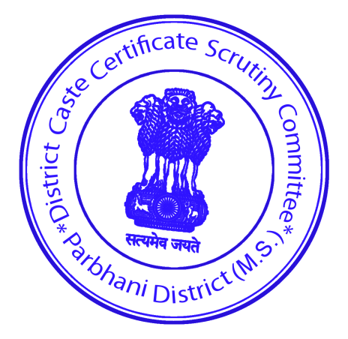
Designation : MEMBER/Dy.Commissioner Social
Welfare
Reason : Caste Validity Certificate
Location : District Caste Certificate Scrutiny Committee
Date : 06-Feb-2025 15:27:23 PM

Member
(Dy.Commissioner Social Welfare)
District Caste Certificate Scrutiny Committee,
District Parbhani

This is digitally signed document, hence is legally valid as per the Information Technology (IT) Act, 2000.
To Verify Authenticity of Validity Certificate, please visit https://ccvis.barti.in/

